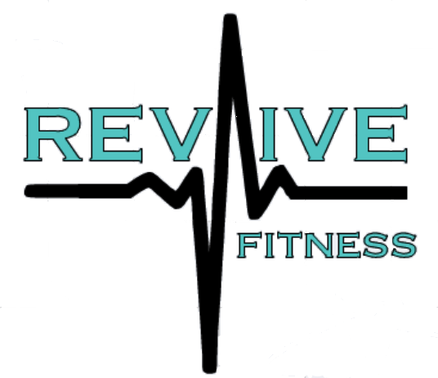

Proposal for Employee Wellness
The following document will provide all information about Revive Fitness’s employee wellness program and what it can do for your company. As health and wellness have gotten more popular over the last two decades, I have found more companies are hiring me to work with their employees to create happier, healthier, more productive workers. Here are the main issues I see with poor employee health that affect companies and how I address those issues followed by some reasons to introduce a wellness plan to your company:

Issues Impacting Employee Health
- Bad nutrition and eating habits
- Lack of exercise
- Tobacco use
- Not sleeping enough
- Drinking little to no water
- Stress, from work or home life
- Obesity/overweight
- Chronic ailments (high blood sugar, blood pressure, cholesterol, low back pain, etc)
- Poor body image, which can lead to low self confidence, which in turn can lead to poor job performance

Additionally, employees who have a “desk” job or a sedentary job where they are not moving much throughout their workday are prone to:
- High blood pressure, high cholesterol, and elevated blood sugar levels
- Increased risk of becoming overweight/obese
- Increased risk of death due to cardiovascular disease or cancer
- Increased rate of bone and muscle loss vs. jobs that aren’t sedentary
- Back pain with increased risk for injury or sciatica
- Poor posture and decreased wrist mobility increasing a chance of carpal tunnel syndrome

Reasons for Implementing a Wellness Plan
- It shows the employee you care about their well being.
- When the employee feels like they are cared for by their company , they feel less like a cog in a machine and more like a human being and an integral part of the team.
- Improved productivity
- When someone learns how to eat properly, exercise, sleep better, or just de-stress, they are more likely to have more energy and a better outlook every day which can lead to increased productivity.
- Lowered health insurance costs
- People that have high blood pressure, high blood sugar, elevated cholesterol, obesity or any other chronic ailments account for most doctors’ office/hospital visits within your worforce. One of the main concerns when meeting with employees is to identify any ailments that we can work towards eliminating through nutrition and exercise.
- Fewer sick days
- Teaching people how to eat properly and get active is a big part of my job. Once an employee consistently takes control of their nutrition and exercise and begins focusing on mental well being, they begin to have a stronger immune system. That leads to fewer missed days due to illness.
- More camaraderie in the work place
- It’s a well-known fact that people taking the same journey together tend to want to share their experience with each other, which ultimately brings them closer together. I have found that when I meet with employees, they tend to keep each other on track and honest on what they should be doing to get healthier. They want to see each other succeed as they are all having the shared experience of working hard and having a goal to accomplish.
- Improved employee recruitment and retention
- If a possible new hire has narrowed their choices down to two potential companies to work for, a wellness plan is a great perk to have to try and sway them. Especially if the plan includes small group or individual personal training. Also true for why a current employee would choose to stay with your company.
- It’s a write off for tax purposes
- Nothing more needs to be said here.
- Will prevent your company from having to hire new employees or train current ones to take over responsibilities of employee that can no longer perform certain tasks due to health issues.
Services
Here is a current list of services I currently offer for corporate wellness. Plans are completely adaptable to an individual company’s wants/needs. If there is something not listed here that your company would be interested in, I am certainly open to adding whatever Is needed :
- One-on-one counseling
- I sit down with each individual and go over the things in their lifestyle they are struggling with and need guidance for. We mainly focus on proper nutrition and incorporating exercise. I give them a plan to follow, and schedule follow ups every two weeks or every month to monitor progress and hold them accountable.
- Lunch and learns
- I put together a presentation that I think will be helpful to most people (how to properly grocery shop, reading nutrition labels, exercising 101, etc.) Company can provide a healthy lunch to eat as I do presentation. Question and answer session after.
- On site small group or individual personal training
- I bring all necessary workout equipment either to work site or another agreed upon location, where I will train a small group of employees that can agree on a time they all can meet. Also available for one-on-one sessions. Company can pay for sessions or split payment with employee.
- Remote personal training through workout app
- I program a month’s worth of workouts into an easy to use app for the employee based on what their goals are and where they will be working out (home, office, gym, etc). App also lets me track when they are checking in to complete workouts and what they are eating to hold them accountable. It also allows us to communicate back and forth if there are questions about specific exercises or diet needs in real time.
- Phone call/FaceTime counseling sessions
- Same as one-on-one counseling sessions. The face to face meetings just provide a more personal touch. This option is for the employee who cant fit a meeting time with me into their work day.
- Company wide challenges
- Can be anything from biggest loser contest, to taking 100,000 steps in a week as a company. Things that bring employees together in their goals to get healthier. Rewards and incentives will help them stay on track.

Working with a small independent company like mine is more beneficial than Plans provided by insurance companies. Most times, these plans are simply limited to phone call check-ins with employees once a month. Employees are not able to ask questions on a daily basis if needed, and must simply wait until their next appointment. They do not offer much in the way of helping the individual make achievable changes to their lifestyle. I provide a more personal approach and realize that each person is different and requires a different approach to what will help that person be successful. I am available to the employees for questions/concerns on a daily basis, as I provide them with all my contact info. I want them to have all the information and guidance necessary to achieve their goals.

Who I work with
I have been fortunate enough to be able to work with the following companies and their employees. For referrals to any of my current clients please let me know and I can get contact information sent to you.
4LP

Petro Guardian
https://petroguardian.com/

Axis Oilfield Rentals
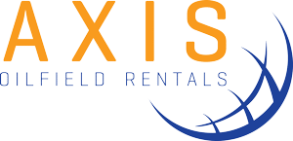
http://axisoilfieldrentals.com/

Kelly Pump and Supply
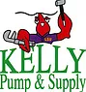
https://www.kellypumpandsupply.com/

RPS insurance, Covington
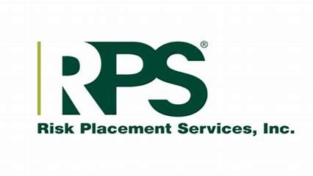
https://www.rpsins.com/

DSLD Homes
https://www.dsldhomes.com/

Relyon
http://relyon.tech/

My business has been steadily growing with more companies customizing wellness programs best suited to their employees. I am always looking for more companies that want to make happier, healthier employees.
I do offer a complimentary lunch and learn for your employees to educate them on basic nutrition and exercise and gauge their interest in continuing to learn and change their lifestyle. Please let me know if you would like more information and we can arrange a meeting to discuss further.

Thank you for your time.

Dwight Wilson, CPT
Owner, Revive Fitness
225.810.0954
www.ReviveFitnessLA.com
ReviveFitnessLA@yahoo.com

